# Testing

For all examples, we will use the following notations:

**1.** *m* − population mean

**2.** *s* − population standard deviation

**3.** *X* − sample mean

**4.** *S* − sample standard deviation

**5.** *n* − sample size

Let us take a few examples and conduct the hypothesis test.

*Z*-test is used when

**1.** We need to test the value of **population mean**, given that population variance is known.

**2.** The population is a normal distribution and the **population variance** is known.

**3.** The sample size is large and the population variance is known. That is, the assumption of normal

distribution can be relaxed for large samples (*n* > 30).

*Z-*statistic is calculated as

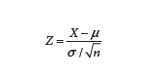

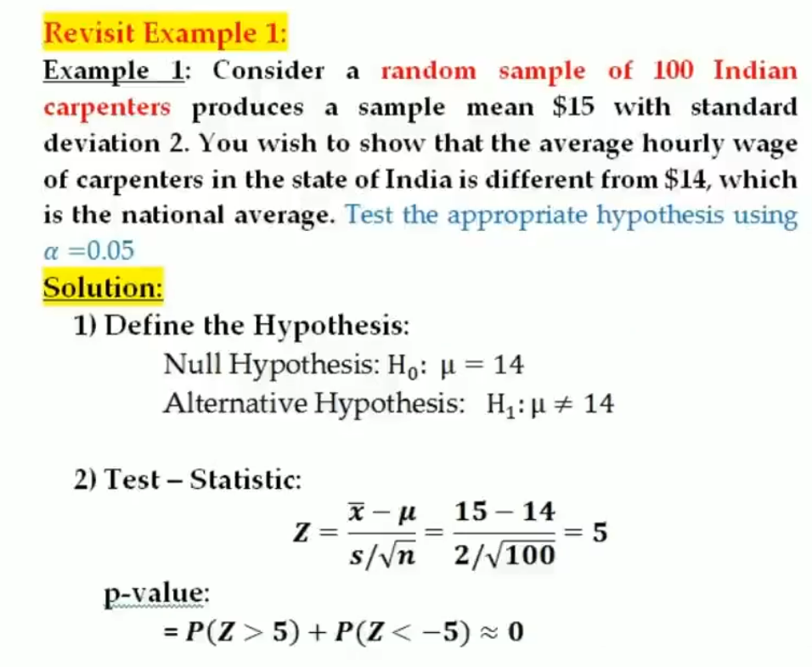

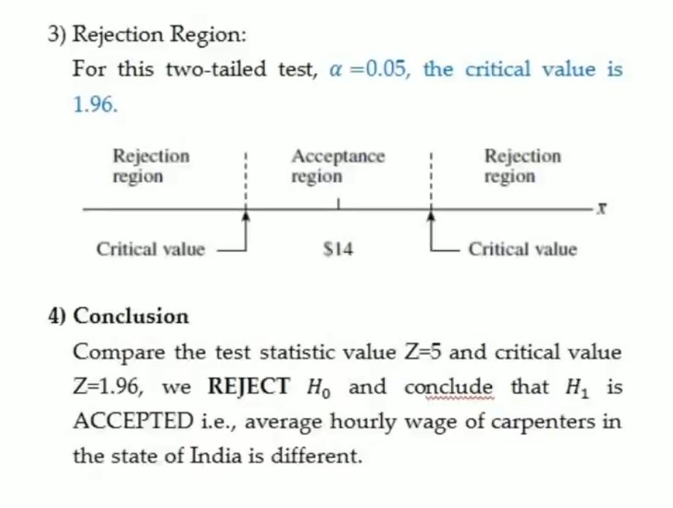

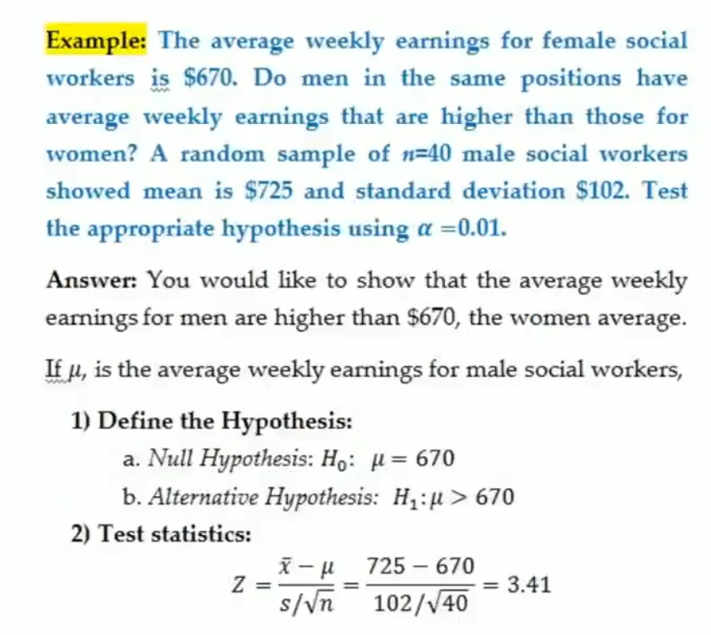

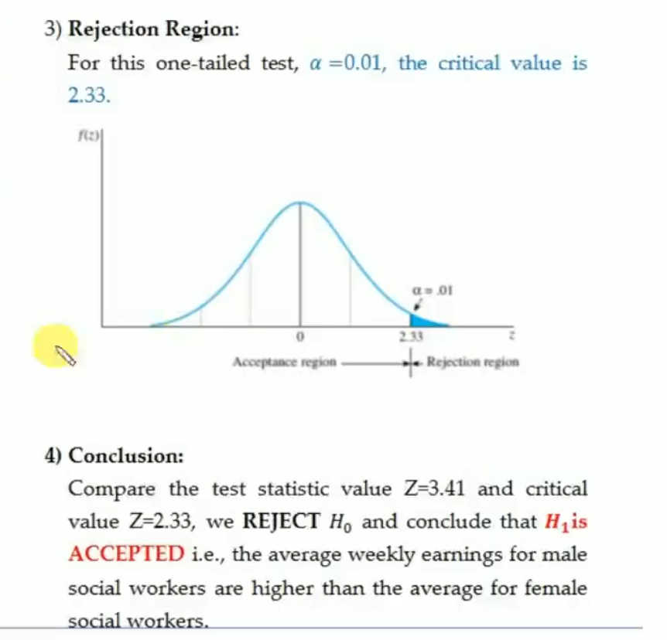

**One-Sample t-Test**

The *t*-test is used when the population standard deviation is unknown (and hence estimated from the

sample) and is estimated from the sample. Mathematically,

